Unit 4 Seasons
Period __1___ Date______
Teaching topic | Reading | 二次备课
Teaching aims | Knowledge Aims:  - Students are able to recognize and understand some new words dry, footstep, kick, snowy, town, wet, etc.  - Students are able to use the sentence structure “What’s the weather like in...” to talk about the weather of four seasons.  - Students can be clear about the festivals of each season.  Ability Aims:  - Students can find out the rhyme of a poem.  - Students are able to summarize the main idea of the paragraph.  - Students can talk about their feelings to the four seasons.  Emotional Aim:  - Students can be aroused their love to the beauty of the nature.
Important points | Help students get the features of the four seasons.
Difficult points | Talk about their feelings about the four seasons.
Teaching Procedures | Step1 Lead-in  - Getting ready: Which season do Hi and Lo like best?  - Question: Which season do you like best? Why?  - Get to know the poem: Footprints  - Match the four seasons and each part of the poem.  - Rhyme: For example “go”and “snow”, the same vowels. Then find out the rhymes of the rest parts.  - Match the pictures and the four seasons.  Step 2 Pre-reading  1. Look at the title and predict what the passage talk about.  2. Discribe the four pictures.  3. Questions 1-4 in the Book 44 B  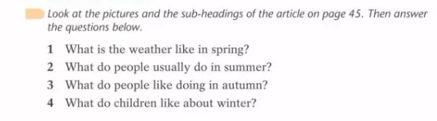  Step 3 While-reading  - Book47 D1  Find out the sentence struture “It is adj to do... ” to go with the four pictures.  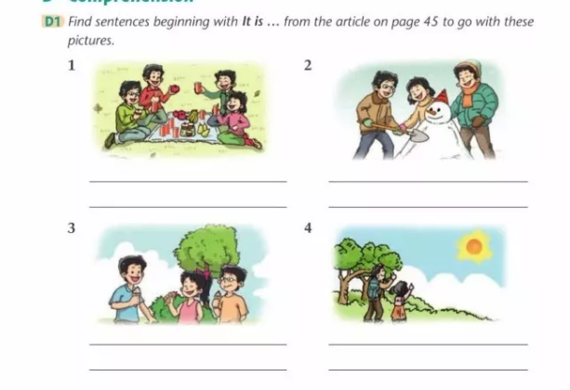  - Book47 D2  Do detail reading and finish the table.  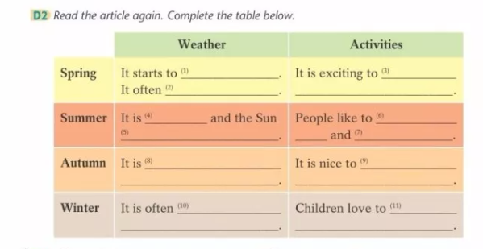  Step 4 Post reading  - Discussion: Which season do you like best? Why?What do you often do in that season? Give more detail information.  - Festivals in each seasons.  拓展：春分日 夏至日 秋分日 冬至日  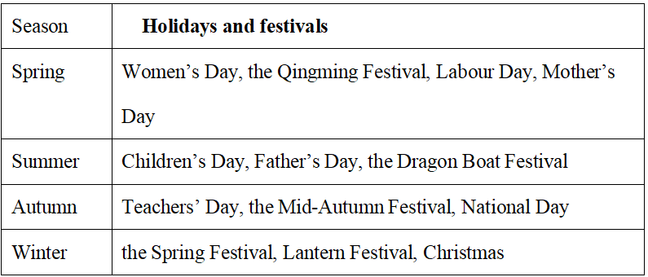  Spring  Women’s Day, the Qingming Festival, Labour Day, Mother’s Day  Summer  Children’s Day, Father’s Day, the Dragon Boat Festival  Autumn  Teachers’ Day, the Mid-Autumn Festival, National Day  Winter  the Spring Festival, Lantern Festival, Christmas
Homework
Reflection
Unit 4 Seasons

Period __2___ Date______
Teaching topic | Reading & Language | 二次备课
Teaching aims | Knowledge Aims:  - Students are able to understand some useful language in the context of the reading text The four seasons.  Ability Aims:  - Students are able to apply the language and vocabulary they have learnt to discuss about the features of the four seasons.  Emotional Aim:  - Students can be feel the different beauty of the four seasons.
Important points | Having a comprehensive understanding of the reading text, including the language points.
Difficult points | Applying the target vocabulary and language to discuss about the topic.
Teaching Procedures | Step1 Review & Lead-in  - Retell the passage45 based on the four pictures.  - Speak out the words based on the phonetic symbols (音标)  Step 2 Focus on language  - Paraphrase the new words: Finish Book 46 C1  - Usage of words and expressions  - start to do sth=start doing sth  start to get warm; start falling  - 系动词+adj，get warm; turn green; turn brown.  - gentle-gently  部分副词变化，去e+ly（特殊记忆）  - everything 不定代词作主语，谓语用三单。（拓展不定代词every-;some-;any-, no-）  - like to = love to  - snow-snowy, n-adj  补充：wind-windy; cloud-cloudy  - spend time with...  四朵金花  sb spend time/money on sth/(in) doing sth.  It takes sb time/money to do sth.  sb pay money for sth.  sth costs sb money.  - It is adj to do sth  It是形式主语，to do 不定式是真正的主语。  - Exercise: Finish Book 46 C2  Step 3 Grouping adjectives Book 46 C3  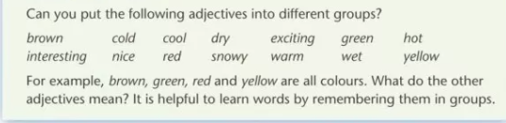  Colours: brown, green, yellow  Weather: cold, cool, dry, hot, snowy, warm, wet  Feeling: exciting, interesting, nice  Step 4 The beauty of the four seasons  What’s the difference of the four seasons?  weather, activity, festivals and what people often do
Homework
Reflection
Unit 4 Seasons

Period __3___ Date______
Teaching topic | Grammar – adj | 二次备课
Teaching aims | Knowledge Aims:  - Students can understand how to change nouns to adjectives.  - Students can know that adjective after the verb am/is/are.  - Students can use “It is adj to do sth” to make sentences.  Ability Aims:  - Students are able to use adj in the correct position.
Important points | The uage of the adjectives.
Difficult points | The meaning of the adjectives.
Teaching Procedures | Step1 Review & Warming-up  - What’s the weather like today?  - What the weather like in spring/summer/autumn/winter?  引导学生说出关于weather的词汇  Step2 Presentation of Grammar  - noun-adj  - +y: rain-rainy  - 双写+y:sun-sunny  - 拓展：+ly:  friend-friendly; love-lovely  - Observe the given examples and workout the rules in textbook.  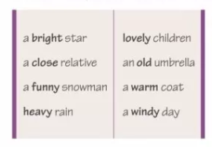  adj+noun  - Subject+linking verb+adj+...  主系表结构  Observe the sentences and find out the position of the adjectives.  The weather starts to get warm.  Everything turns green.  The weather is hot in summer.  Leaves turn brown, red or yellow.  The weather is cool and dry.  Winter is often cold and snowy.  adj在系动词后面  常见系动词：be动词、感官动词、变化系动词（get\turn\become）、持续系动词(keep\remian\stay)  - It is adj (for sb) to do sth  做...是adj的  It：形式主语  不定式to do ：真正的主语  拓展：区别  It is adj for sb to do sth: adj表示性质  It is adj of sb to do sth:adj表示品质  Step 3 Controlled practice  Book49-51  Step 4 Productive task  Discussion:What else do you know about adj.  -ing/-ed区别; 比较级最高级
Homework
Reflection
Unit 4 Seasons
Period __4___ Date______
Teaching topic | Listening | 二次备课
Teaching aims | Knowledge Aims:  - Students can get the main information with the help of the pictures.  - Students can know the weather in Canberra.  Ability Aims:  - Students use the given information from the table to predice the blanks.  Emotional Aim:  - Students are able to feel the beauty of Canberra..
Important points | Students can get the information about the weather in Canberra.
Difficult points | How to take notes fast while listening.
Teaching Procedures | Step1 Lead-in  Q:What’s weather like in Guangzhou in spring/summer/autumn/winter?  Step2 Pre-listening  Canberra is a city in the south of Australia.  - Match the four pictures and the four seasons.  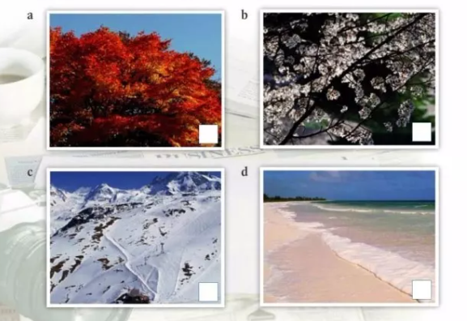  - Describe the four pictures.  Step 3 While-listening  - Number 1-4 in the boxes.  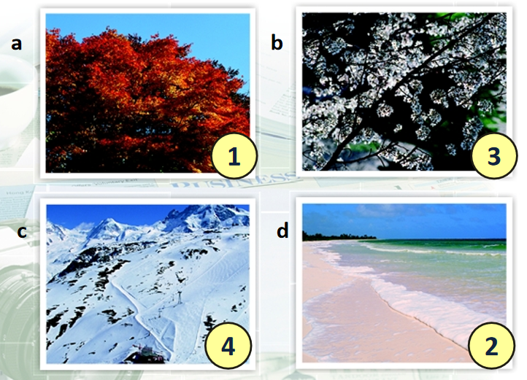  - Listen again and complete the table below.  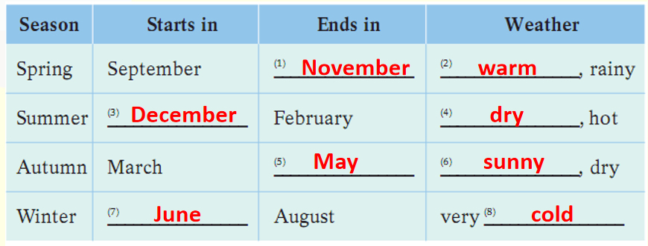  - Detial listening  What is Kelly’s favourite season?  What do the trees look like in spring?  Where does Kelly usually go in summer?  How long does she usually stay there?  What do the leaves on the trees look like in autumn?  Where do some people like going in winter?  What does Kelly usually do in winter?  Step 4 Post-listening  What are the differences between the four seasons in China and those in Australia?
Homework
Reflection

Unit 4 Seasons
Period __5___ Date______
Teaching topic | Writing | 二次备课
Teaching aims | Knowledge Aims:  - Students are able to describe the four seasons from weather, festivals and activities.  - Students can write about their favourite season by imitating the exmaple writing.  Ability Aims:  - Students are able to develop their writing skill by imitating writing.  Emotional Aim:  - Student can be aroused to enjoy the beauty of different seasons.
Important points | Write about their favourite season by imitating the exmaple writing.
Difficult points | Describe the four seasons from weather, festivals and activities.
Teaching Procedures | Step1 Review and lead-in  What’s the weather like in Canberra in spring/summer/autumn/winter?  Step 2 Pre-writing  - Read Many’s writing and answer the quetions.  What is Mandy’s favourite season?  What is the weather like in Mandy’s favourite season?  What things can she do in this season?  Is there a festival or holiday in this season? What is it?  What does she eat at this festival or holiday?  What does she like about this festival or holiday?  - Review the festivals in the four seasons and activities of the festivals.  Step 3 While-writing  Imitating Mandy’s passage and write an article: My favourite season  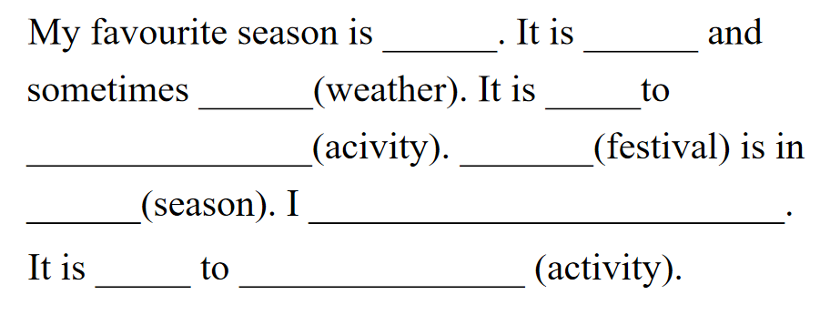  Step 4 Post-writing  Speak-up  Give a speech of my favourite season.
Homework
Reflection
Unit 4 Seasons
Period __6___ Date______
Teaching topic | Speaking & Culture Corner | 二次备课
Teaching aims | Knowledge Aims:  - Students are able to recognize the phonetic symbol /ə/, /ɜː/, /l/, /h/, /r/and their corresponding letter groups.  Ability Aims:  - Students are able to pronounce words with the taught letter groups correctly.
Important points | Learning the pronunciation and writing of the phonetic symbol /ə/, /ɜː/, /l/, /h/, /r/
Difficult points | Pronouncing the taught letter groups properly.
Teaching Procedures | Step1: Learn the vowel sound-- /ə/  1. monophthong /ə/ is the sound of the letters: a, o, er, or, ure, ect.  2. Read the words have the sound of /ə/.  about banana China  complete today tomorrow  rubber river teacher  actor doctor monitor  future picture pleasure  Step2 Speaking  Learn the vowel sound /eI/  1. monophthong /eI/ is the sound of the letters: a , ay, ai, ect.  2. Read the words have the sound of /eI/.  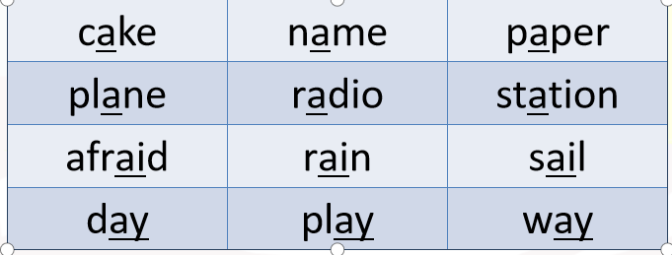  Learn the vowel sound 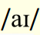  1. monophthong is the sound of the letters: i , y, ect.  2. Read the words have the sound of .  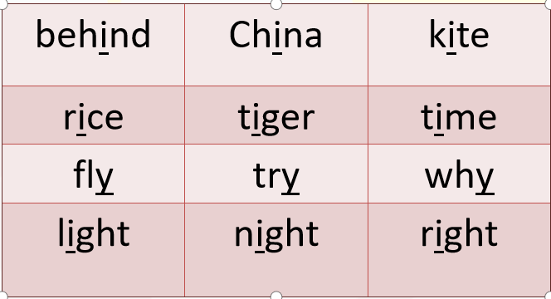  Learn the vowel sound 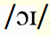  1. monophthong /eI/ is the sound of the letters: oy , oi, ect.  2. Read the words have the sound of .  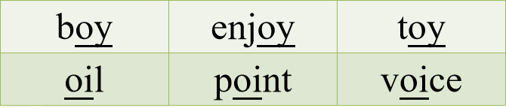  Learn the vowel sound /m/ and/n/  Read the words have the sound of /m/ and/n/.  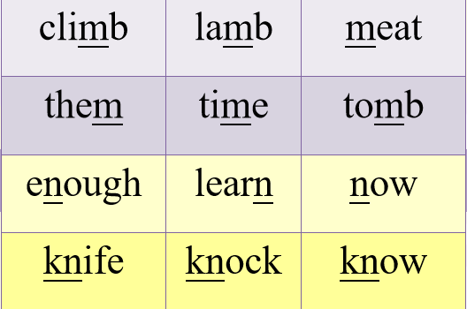  Learn the vowel sound 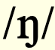  Read the words have the sound of .  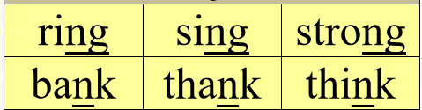  Pay attention to the difference between the sound of /n/ and  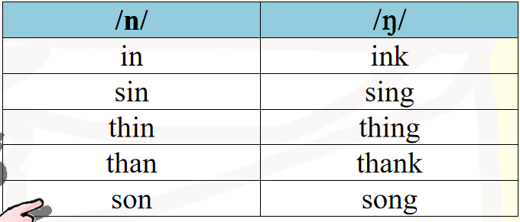  Step3 Control Exercise  A1 Listen carefully and circle the word you hear from each pair.  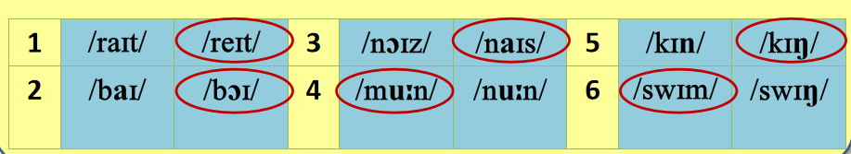  A2 Read these sentences. Pay attention to the letters in bold.  Step4 Productive exercise  Make dialogue: My favourite season  Step5 Culture corner  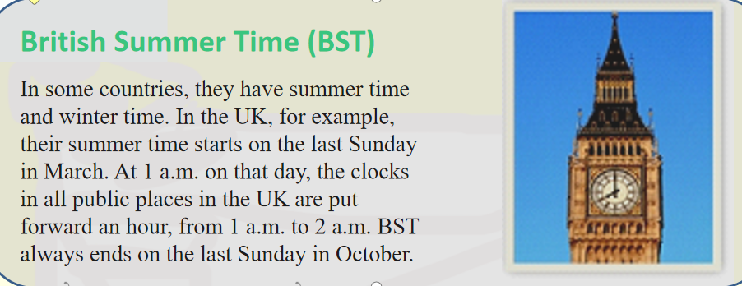
Homework
Reflection
Unit 4 Seasons
Period __7___ Date______
Teaching topic | More practice & Project | 二次备课
Teaching aims | Knowledge Aims:  - Students can know the weather in the different parts of China.  - Students can master some new expressions in the passage.  Ability Aims:  - Students can sort a passage by using a table.  - Students can talk about the weather in their hometown.  Emotional Aim:  - Students can be aroused to love their own hometown.
Important points | The weather in the different parts of China..
Difficult points | Talk about the weather in their hometown.
Teaching Procedures | Step1 Pre-reading  - Show students 4 pictures of different places of China. Let students talk about their weather in the four seasons.  Hainan, Kunming, shanghai, Harbin  - Show them a compass(指南针) and let them tell the directions.  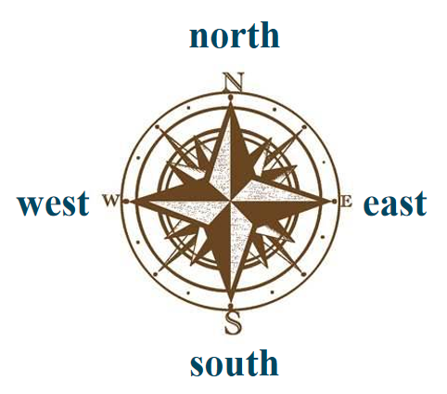  - What do the four cities blong to?  Hainan, Kunming, shanghai, Harbin  The south of China/The north of china  Step 2 While-writing  Read the passage and fill in the tables.  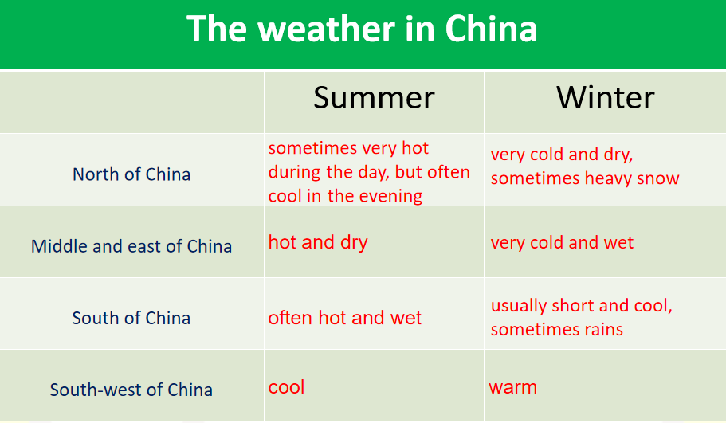  Step 3 Post-writing  Weather reporter  Harbin, Beijing, Lhasa, Hongkong  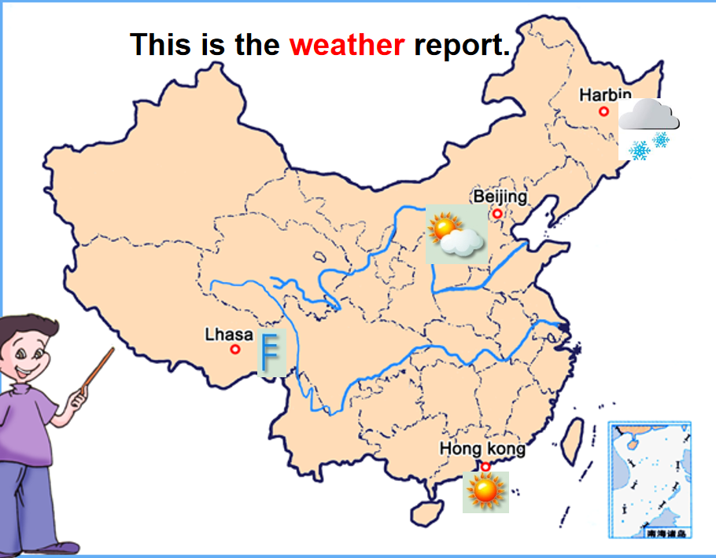  Step 4 Project : Our home town  Answer the questions with your partners.  - Where is your home town?  - Which province is your home town in?  - Is there any big sea or river close to or in your home town?  - When does each season start and end?  - What is the weather like in each season?  - What do people usually do in different  seasons?
Homework
Reflection

