Unit 8 Collecting things
Period __1___ Date______
Teaching topic | Reading | 二次备课
Teaching aims | Knowledge Aims:  - Students are able to recognize and understand some new words doorbell,everywhere,follow,free,front,granddaughter,grandson,hardly,inside,model,newspaper,push,should,silver,soon,space,stamp,unusual and the phrases:living room,etc.  - Students are able to understand and use the sentence “I’m a collector of_______.This is my collection of_______”.  Ability Aims:  - Students are able to understand the structure:a story in the form of dialogue.  - Students are able to understand and use the sentence “I’m a collector of_______.This is my collection of_______” to introduce their interest and hobbies.  - Students are able to guess the meaning of the new words in the specific context.  Emotional Aim:  - Students are able to arrange the timetable of interest and study.
Important points | Get to know the main idea and some key details of the article..
Difficult points | Understand some personal pronouns mentioned in the article.
Teaching Procedures | Step1 Lead-in  T. Show Ss pictures of the getting ready to learn about the topic.  T. sets a brainstorming task.  Open-class Feedback(FB).  T.draws Ss.’ attention to the pictures on P.86 and know about different collections .  Learn the set of same-rooted word:collect collector collection  T.sets. another brainstorming task: Do you collect things?What’s your collection?  Open-class FB.  Step 2: Pre-reading  T.sets prediction task p.100 B.  T. draws Ss.’attention to the title and pictures.  Ss. finish the task individually according to the pictures and titles.  Nomination for FB.  Ss. look at the picture to answer the following questions:  How many people?Who are they?What do they talk about?  Nomination for FB.  T. draws Ss.’attention to the form and structure of the text.  Step 3:While-reading  1.First reading  T. sets the reading task:fill in the blanks  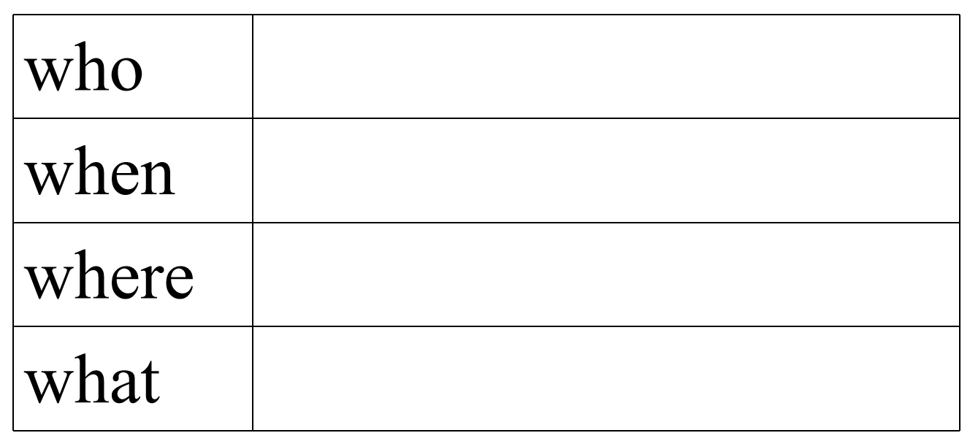  Ss. finish it individually.  Nomination for FB.  2.Second reading  T. sets the reading task:  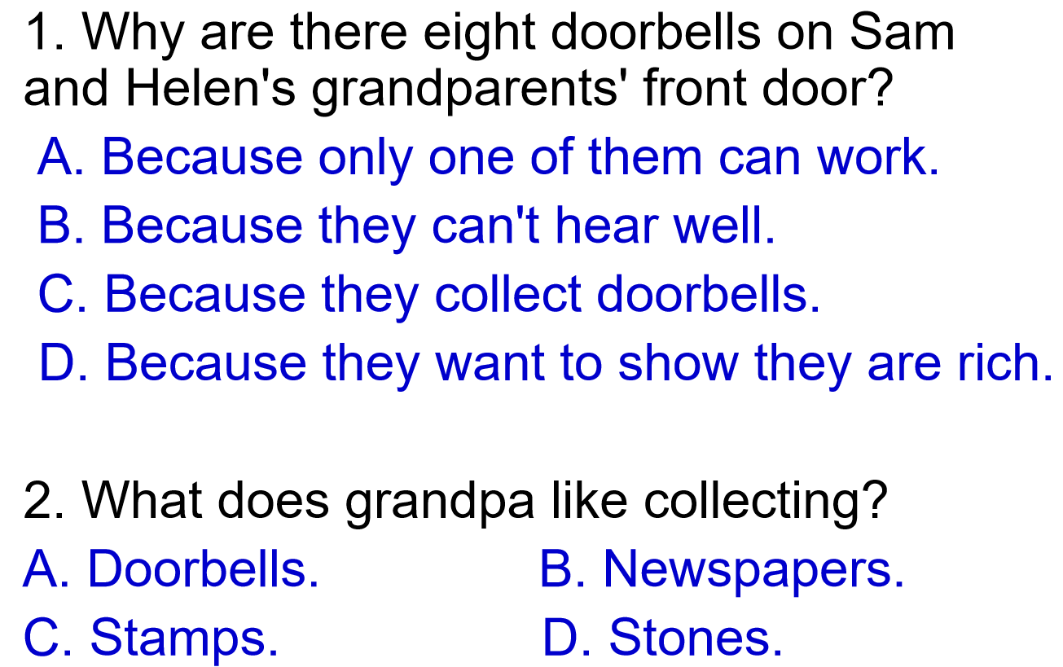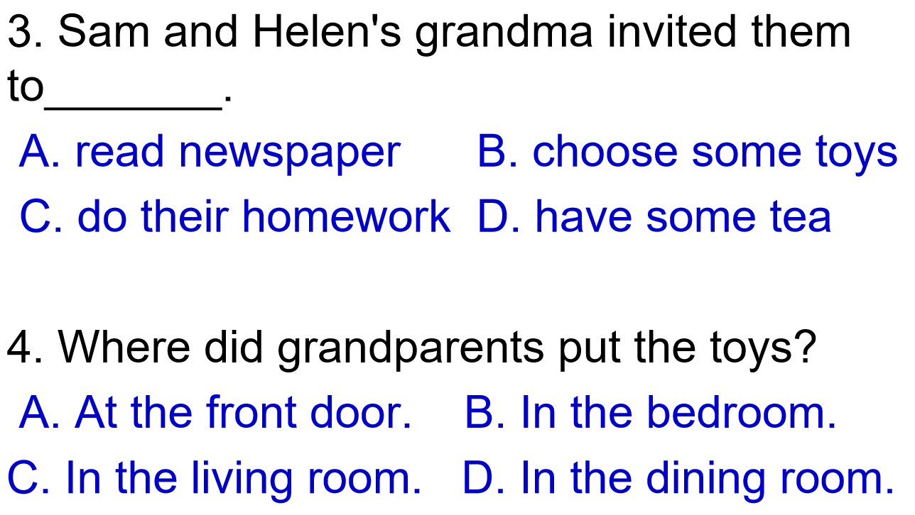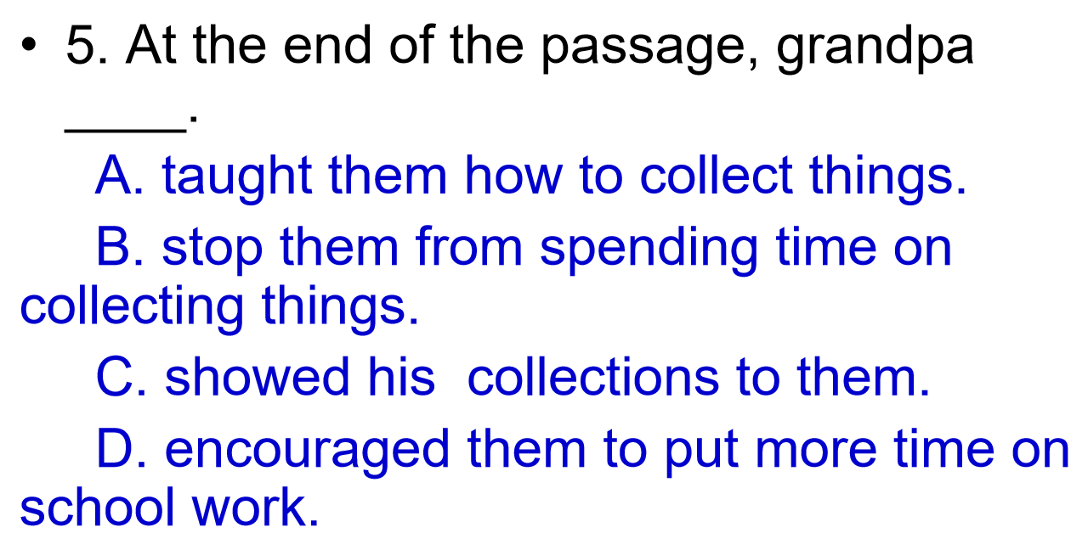  Ss. finish it individually. Nomination for FB.  Find out where can we get the answers.Underline and learn some key words,such as doorbell,granddaughter,grandson,hardly,inside,unusual  and the phrases:living room,etc.  3.Third reading  T. sets the reading task: P101 D1 &D2.  Step 4 After reading （choose one of the the following tasks according to your students’ level）  - Role-play the article.（for A3 level）  - Retell the article with a mind-map.（for A1-2 level）  - Group work: P103 D3. （for A4-5 level）  Ss discuss in groups.Nomination for FB.
Homework
Reflection
Unit 8 Collecting things
Period __2___ Date______
Teaching topic | Reading & Language | 二次备课
Teaching aims | Knowledge Aims:  - Students are able to understand some useful language in the context of the reading text ‘unusual collections’.  Ability Aims:  - Students are able to apply the language and vocabulary they have learned to discuss about the topic.  Emotional Aim:  - Students are able to know different collections and cultivate their own interest.
Important points | Having a comprehensive understanding of the reading text, including the language points.
Difficult points | Applying the target vocabulary and language to discuss about the topic.
Teaching Procedures | Step1 Review & Lead-in  Ss. read aloud the new vocabulary and reading text before the lesson.  T. sets a review task: gap-filling.  Ss. in pairs fill the gaps with new vocabulary to complete the text.  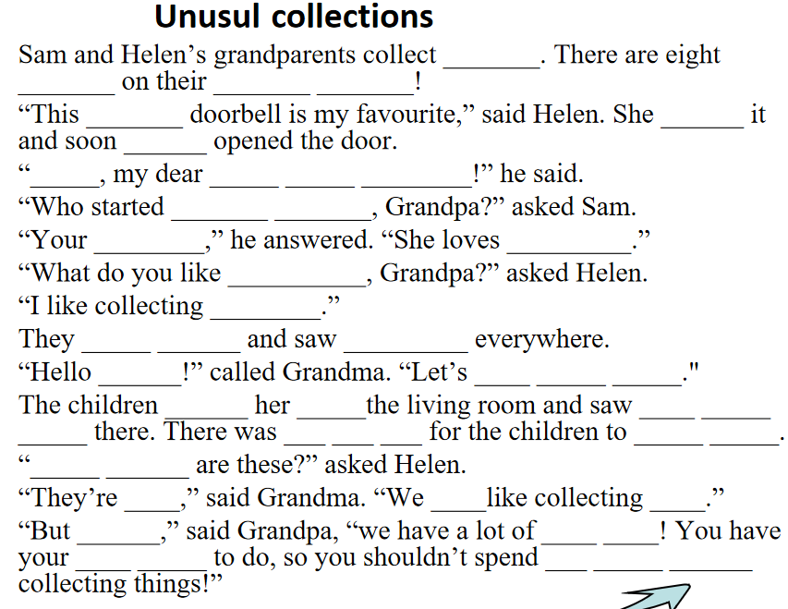  Nomination for FB.  Step 2: Focus on language  - nominates to check some useful phrases and important sentence in the reading text.  1.Unusual collections  unusual = un + usual,un- 表否定意义  Have a try:  不开心的 unhappy  不健康的 unhealthy  不友善的 unfriendly  不幸的 unlucky  2.“Who started collecting doorbells, Grandpa?”  start doing sth.开始做某事,相当于begin doing sth.  start 还可以接动词不定式，即start to do sth.  3.There was hardly any space for the children to sit down.  hardly 几乎不,表否定意义  注意与hard区分开来  Hard: (1) adj. 硬的 (2) adj. 难的 (3) adv. 努力的  hardly用于be动词、情态动词后面，行为动词前面  Have a try:  我几乎看不到那架飞机了。  I can hardly see that plane.  周末我几乎不看电视。  I hardly watch TV at weekends.  4.We both like collecting toys.  both 两者都，常与and搭配其后的动词用复数形式  Have a try:  安和莉莉都喜欢看书。  Both Ann and Lily like reading.  5.… you shouldn’t spend too much time collecting things.  shouldn’t 为情态动词should的否定形式，意为不应该，  后面接动词原形  6.… you shouldn’t spend too much time collecting things.  (1)spend some time/ money (in) doing sth.花时间/金钱做某事  其他用法：spend some time/ money on sth.  Have a try:  妈妈每天花许多时间做家务。  Mom spends much time (in) doing housework every day.  我每晚花几个小时在功课上。  I spend several hours on my homework.  (2)too much 意为“太多”，修饰不可数名词。其也可以作  副词性短语，修饰动词；还可以作名词性短语，用作  主语或宾语。如：  昨天晚上我喝太多可乐了。  I drank too much cola last night.  她说的话太多了。  She talks too much.  太多事情同时发生了。  Too much was happening at the same time.  【拓展】much too 意为“太；非常”，用来加强语气，修饰形容词或副词。如：天气实在太冷了。 It's much too cold. too many 也意为“太多”，但其后接可数名词的复数形式。如：他有太多书了。He has too many books. 请选用too much，much too或too many填空。1. You gave me __________.2. You're driving __________ fast.3. He has __________ homework to do today.4. Some children play computer games __________.5. There are _______ students in the bus. It's very dangerous.Step 3:Practice  学评P141 Reading  Step 4:Summary
Homework
Reflection
Unit 8 Collecting things
Period __3___ Date______
Teaching topic | Grammar -- pronouns | 二次备课
Teaching aims | Knowledge Aims:  - Students are able to understand the meaning and usages of the pronoun.  Ability Aims:  - Students are able to master the basic usage of pronouns.  Emotional Aim:  - Students are able to talk something with pronouns properly.
Important points | Master the basic usages of pronouns.
Difficult points | Understand the difference between object pronouns and possessive adjectives.
Teaching Procedures | Step1 Review & lead-in  - Ss. read aloud the new vocabulary and reading text before the lesson.  Ss. have a dictation task.  T.Show some sentences with personal pronouns in the text Ss. to review the reading text.  Nomination for FB.  Step2: Presentation of Grammar A:personal pronouns  T. sets discovery task: observe the above sentences and find out the similarities & difference.  Ss. discuss in groups.  Nomination for FB.  T. shows more model sentences and guide students to work out the rules.  Ss. observe the given examples and work out the rules in textbook on P91.Then try to remember some irregular verbs on P105.  Finish the practice on P105 to get a better understand the rules of how to change nouns into pronouns and use personal pronouns correctly.  Nomination for FB.  Step 3: Presentation of Grammar B: possessive adjectives and possessive pronouns  T. sets discovery task: observe the above sentences and find out the similarities & difference.  Ss. discuss in groups.  Nomination for FB.  T. shows more model sentences and guide students to work out the rules.  Ss. observe the given examples and work out the rules in textbook on P106.Then try to remember the difference between it’s and its on P106.  Finish the practice on P107 to get a better understand the rules of how to change nouns into pronouns and use them correctly.  Nomination for FB.  Step 4: Productive task:  T. ask ss. to make sentences with possessive pronouns to show that something belongs to someone or something.  Step 5: Summary
Homework
Reflection
Unit 8 Collecting things
Period __4___ Date______
Teaching topic | listening & speaking | 二次备课
Teaching aims | Knowledge Aims:  - Students are able to read and understand the new words interview, magazine, really, sentence, something and the phrases be bad for, be interested in.  - Students are able to recognize the phonetic symbol /t/, /d/, and their corresponding letter groups.  Ability Aims:  - Students are able to understand the meaning and usage of the key word “but” that it usually introduce a different idea.  - Students are able to ask and talk about the collections .  Emotional Aim:  - Students are able to raise their awareness of discovering the rules without teachers' help by observation and discussion.
Important points | Understand the meaning and usage of the key word “but” that it usually introduce a different idea.
Difficult points | Students are able to ask and talk about the collections .
Teaching Procedures | Step1. Revision  Have a short test,to go over the personal pronouns and possessive adjectives and possessive pronouns.  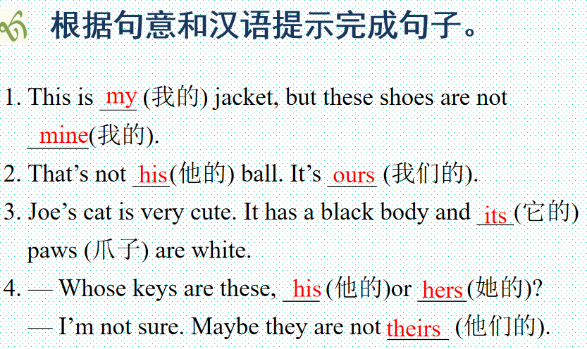  Step2. Pre-listening  Ask Ss:Do you have any collections?  - Prediction: (听前预判)Look at the title and boxes on P104,try to guess the meaning of some new words.  - Learn the new words: Get Ss to learn some new words by showing some pictures.(interview, magazine, really, sentence, something and the phrases be bad for, be interested in.)  - Focus on the Top tip:Pay attention to the words after “but”.  Ask Ss:When people say “but”, what are they going to say next?  Step3.While listening  - Get the Ss to Listen to a TV reporter interviewing three people about students’ collections. Who says the sentences below? Put a tick (√) in the correct boxes. (finish Exercise A on page 104)  2. Play the recording again for the Ss to listen and complete the table (Get students to practice the strategy. Focus on the listening strategy: listening of key words )  3.Check the answers.  4.Show the listening script and learn some phrases: Deal with some useful phrases and expressions in the passage. Guide the Ss to learn and use them in their own speaking.Get ready for the following part of speaking.  1)be bad for:拓展：do harm to, be good for, do good to  2)be interested in; 拓展：be keen on/do well in/ enjoy doing/like doing/love doing  Step4.Speaking:  - Recognize the phonetic symbol /t/, /d/, and their corresponding letter groups.  - Work in groups, and work out the structure of asking & introducing a collection of yourself.Use the structure to talk about your collection.  - Showtime.  Step 5:.Summary: Ask the Ss to summarize what we have learned today.  Step6.Homework S  Finish related exercises in Students Times.  Step7.Self-assessment
Homework
Reflection
Unit 8 Collecting things
Period __5___ Date______
Teaching topic | More practice | 二次备课
Teaching aims | Knowledge Aims:  - Students are able to recognize and understand some new words interview,magazine,really,sentence,something and some phrases be bad for,be interested in,etc.  Ability Aims:  - Students are able to understand the main idea of the article.  - Students are able to talk about their opinions about collecting.  Emotional Aim:  - Students are able to raise their awareness of collecting properly.
Important points | Recognize and understand some new words.  Understand the main idea of the article.
Difficult points | Talk about their opinions about collecting.  Learn some language points.
Teaching Procedures | Step1. Leading-in  - Ask Ss sth about Collection.  Q1:Do you think that your collection is educational?  Q2:Do you think that collecting stamps is educational?  Step2. Reading 1  1. Pre-reading  Get the Ss to look at the 4 questions on page110.  1). What did Daniel show his classmates?  2). What made Daniel more interested in Chinese culture?  3). What did Daniel learn from the stamps?  4). What does Daniel think of collecting stamps?  2.While--reading  1)Get the Ss to listen to tape and finish the exercise on page 110.  2)Play the tape again and ask the Ss to write down the answers (Don’t look at the text)  3)Ask the Ss to read the text and check if their answers are correct only by listening to the tape.  4)Check the answers:  3.Post reading:P110 B  T.What do you think of collecting?In groups,tell your classmates your opinions.  Step3. Reading 2 Learn some phrases and language points  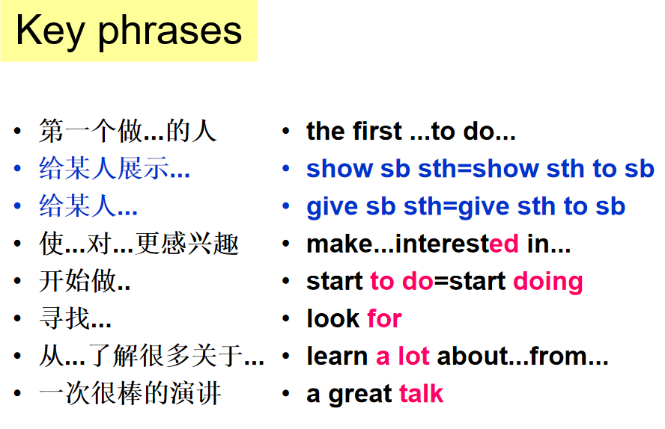  make sb. interested in sth.使某人对某事感兴趣  learn a lot about sth. from ...从某物中学习很多.....  Doing sth. is+ adj. 做某事是...  Step4. Productive task: Give a short speech  T. Use some key words below and give s short speech about your own collection.  Hello, everyone. I want to talk about my collection.  My father/mother/teacher......This made me...  Now......I learnt...about...  Collecting ...is ...  This is my collection of .... Thank you for listening.  Step5.Summary &Homework
Homework
Reflection
Unit 8 Collecting things
Period __6___ Date______
Teaching topic | Writing & Study skills&Culture corner | 二次备课
Teaching aims | Knowledge Aims:  - Students are able to write a short article about their collection.  Ability Aims:  - Students are able to develop their ability of creating their own pieces of writing by analyzing and imitating a model text.  - Students are able to learn something from a postcard.  Emotional Aim:  - Students are able to cultivate their interest of collection and postcards.
Important points | Creating their own pieces of writing by analyzing and imitating a model text.
Difficult points | Use what we have in this unit to write an article about the collection.
Teaching Procedures | Step1 Lead-in  T. show some postcards to attract ss.  Brainstorm “What should a postcard contain?”  Nomination for FB.  Step 2: Pre-writing  1.T. show the postcard on p109,and introduce the two parts: body and picture.  Ss. read the postcard of the Harry and learn the new words:over,work of art.  2.T.Analyse the structure of Harry’s model writing.Lead ss to imitate it.  Step 3: While-writing  T. sets the writing task.  Ss. create their own writing by applying the language they've learnt and the analysis of model text.  Step 4: Post-writing  T. ask ss to show their writing and introduce it to the class.  Open-class FB.  Step 5: Study skills&Culture corner  T. shows some postcards and asks: What can we learn from a postcard?  Ss. discuss in groups.  Nomination for FB.  T. adds more details.  Ss. work in groups and discuss their favourite postcard to their classmates.  Nomination for FB.
Homework
Reflection

