**（九年级上册六单元1课时）教学设计**

广州市花都区花广金狮学校 黄丹仪

1. **教学材料**

Level: Junior Three  
Teaching Material: Oxford English Book6A P82-P83

Teaching content: Unit6 What's a balanced diet?  
Lesson type: Reading

Lesson length: 40 minutes

**二、教学内容分析**

本单元以“健康饮食”为话题，以均衡饮食健康饮食习惯为主线。

学生在阅读(Reading)板块阅读一段有关均衡饮食的对话，了解什么是均衡饮食以及均衡饮食对健康的重要意义；在听力(Listening)板块听一段订餐电话，了解点餐的表达方法，并帮助服务员完成顾客的点单，巩固获取和记录关键信息的听力技能；在语法(Grammar)板块学习宾语从句的结构和用法；在口语(Speaking)板块的功能意念(Talk time)部分，学习表达自己的偏好，然后在会话(Speak up)部分以小组为单位，通过讨论为本校学生设计一周的午餐菜单；在写作(Writing)板块学习餐馆点评的结构，并能仿照范文，就自己曾就餐的一家餐馆换写一则点评;在补充阅读(More practice)板块阅读中外两首描述农夫耕作的诗歌，回答问题并比较两首诗歌的异同，在文化角(Culture corner)板块了解有关西红柿的有趣故事;在课题(Project)板块通过小组合作，选择某个国家的一种典型美食，撰写一份制作这种食物的食谱。

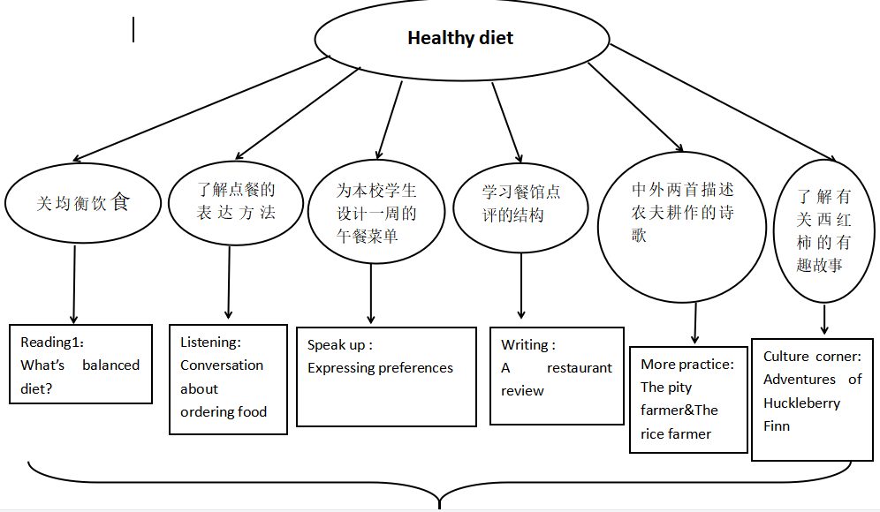

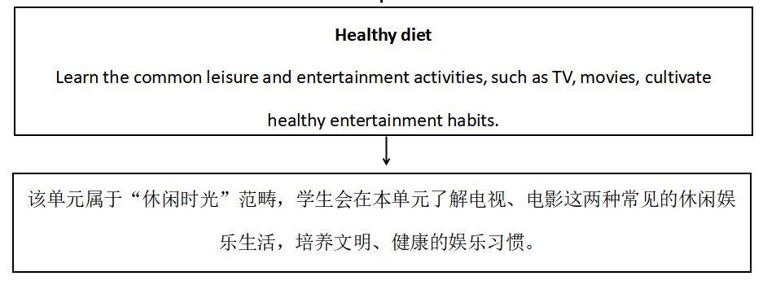

**三、单元教学目标：**

* Knowledge Aim: students are able to acquire the basic usage of some words and phrases about balanced diet;
* Ability Aims: students can have a further understanding of the passage what is a balanced diet by using the reading subskills of skimming, scanning, detailed reading and inferring.
* Emotional Aim: students can understand the importance of keeping a balanced diet.

**四、课时教学目标：**

* Students will be able to remember some useful words and sentences.
* Students will be able to understand the article by by using the reading subskills of skimming, scanning, detailed reading and inferring.
* Students will be able to know how to introduce your diet.
* Students will be able to the importance of keeping a balanced diet and value the time and health.

**五、学情分析：**

* Students in this class are usually concentrated in English classes. Most of them are outgoing and good at English, while some of students do not have great interest in English, so it is challenging to get them involved.
* Students may have some background knowledge of balanced diet, which may help understand the article, but they may lack topic-related vocabulary, reading skills ,deep learning of a reading text and logical thinking ability.

**六、教学重难点：**

* Important point: To understand the article’s structure and what is a balanced diet.
* Difficult point: To understand the importance of keeping a balanced diet how to keep a balanced diet.

**七、教学资源：**Textbook; PowerPoint slides; student worksheets; Multi-media, a blackboard and chalks.

**八、教学过程：**

|  |  |  |  |  |  |  |
| --- | --- | --- | --- | --- | --- | --- |
| 教学环节 | 教师活动 | 学生活动 | 设计意图 | 教学评价形式 | 评价内容 | 评价标准 |
| **Warming-up& lead-in**  **(5’)** | **T.**   1. Greeting 2. Lead students to watch a argument between two students. | **Ss.**   1. Greeting. 2. Watch a argument between two students. | To arouse students’ interest and lead the topic. | Teacher evaluation |  | Accuracy |
| **Pre-reading**  **(2’)** | **T.**   1. Lead students to look at the pictures and the title on the book and predict the content. | **Ss.**  1. Look at the pictures and the title on the book.Then answer the questions below. | To arouse students’ interest in the topic of this unit and prepare for the learning of the article. | Teacher evaluation |  | Accuracy |
| **While-reading(15’)** | 2. Ask students to read the article quickly and skim the story divide it into three part and match the main ideas. 3. Ask students to read Lines 2-6 to find out what Samuel and Doris ordered. 4. Ask students to read Lines 4-10 and choose the right answer. 5. Ask students to read 11-15 and fill in the blanks. 6. Ask students to read Lines 16-30, then complete the form.Decide whether the sentences are T (True) or F (False). 7. Guide students to infer the conversation. | **Ss.**  1.Skim the story divide it into three part and match the main ideas.  2.Read Lines 2-6 to find out what Samuel and Doris ordered.Then answer the question.  3.Read Lines 4-10 and choose the right answer. 4.Read 11-15 and fill in the blanks.  5.Read Lines 16-30, then complete the form .Decide whether the sentences are T (True) or F (False).  6.Students to infer the conversation. | 1. To have a quick understanding of the article. 2. To help students better comprehend the article. | Teacher evaluation |  | Accuracy |
| **Post-reading**  **(15’)** | **T.**  1.Guide students to make some comments on Samuel’s diet.  and give some suggestions on his diet. 2.Group discussion. | **Ss.**  1.Make some comments on Samuel’s diet.and give some suggestions on his diet.  2.Discuss with group members. | 1. To check students’ understanding of the article. 2. To cultivate their cooperation ability and train their oral English. | Teacher evaluation  Group evaluation | Discussion | Ability of observing and thinking |
| **Summary&**  **Homework**  **(3’)** | **T.**   1. Conclusion with a video. 2. Self- assessment. 3. Write an article. | **Ss.**   1. Self check what they have learned in this lesson. 2. Try to use the words and phrases they have learned to write an article. | To guide students to apply what they have learned. | Teacher  evaluation |  | Accuracy |

**九、板书设计**

|  |  |
| --- | --- |
| **微信截图_20221121221808** |  |

附学案

**Unit 6 What’s a balabced diet**

**Reading**

**Step4 Groupwork**

**1. 1.Make some comments on Samuel’s / Yihui’s diet.**

**2. Give some suggestions on his diet.**

Eg.

In my opnion, his/her diet is\_\_\_\_\_\_\_\_\_ because\_\_\_\_\_\_ are healthy /unhealthy food , which can provide us with\_\_\_\_\_\_contain(包含，含有)\_\_\_\_.(One group member)

To improve his/her diet, I suggest that he should.../He/She'd better.../It is ...for... to...(Three group members give your advice)

\_\_\_\_\_\_\_\_\_\_\_\_\_\_\_\_\_\_\_\_\_\_\_\_\_\_\_\_\_\_\_\_\_\_\_\_\_\_\_\_\_\_\_\_\_\_\_\_\_\_\_\_\_\_\_\_\_\_\_\_\_\_\_\_\_\_\_\_\_\_\_\_\_\_\_\_\_\_\_\_\_\_\_\_\_\_\_\_\_\_\_\_\_\_\_\_\_\_\_\_\_\_\_\_\_\_\_\_\_\_\_\_\_\_\_\_\_\_\_\_\_\_\_\_\_\_\_\_\_\_\_\_\_\_\_\_\_\_\_\_\_\_\_\_\_\_\_\_\_\_\_\_\_\_\_\_\_\_\_\_\_\_\_\_\_\_\_\_\_\_\_\_\_\_\_\_\_\_\_\_\_\_\_\_\_\_\_\_\_\_\_\_\_\_\_\_\_\_\_\_\_\_\_\_\_\_\_\_\_\_\_\_\_\_\_\_\_\_\_\_\_\_\_\_\_\_\_\_\_\_\_\_\_\_\_\_\_\_\_\_\_\_\_\_\_\_\_\_\_\_\_\_\_\_\_\_\_\_\_\_\_\_\_\_\_\_\_\_\_\_\_\_\_\_\_\_\_\_\_\_\_\_\_\_\_\_\_\_\_\_\_\_\_\_\_\_\_\_\_\_\_\_\_\_\_\_\_\_\_\_\_\_\_\_\_\_\_\_\_\_\_\_\_\_\_\_\_\_\_\_\_\_\_\_\_\_\_\_\_\_\_\_\_\_\_\_\_\_\_\_\_\_\_\_\_\_\_\_\_\_\_\_\_\_\_\_\_\_\_\_\_\_\_\_\_\_\_\_\_\_\_\_\_\_\_\_\_\_\_\_\_\_\_\_\_\_\_\_\_\_\_\_\_\_\_\_\_\_\_\_\_\_\_\_\_\_\_\_\_\_\_\_\_\_\_\_\_\_\_\_\_\_\_\_\_\_\_\_\_\_\_\_\_\_\_\_\_\_\_\_\_\_\_\_\_\_\_\_\_\_\_\_\_\_\_\_\_\_\_\_\_\_\_\_\_\_\_\_\_\_\_\_\_\_\_\_\_\_\_\_\_\_\_\_\_\_\_\_\_\_\_\_\_\_\_\_\_\_\_\_\_\_\_\_\_\_\_\_\_\_\_\_\_\_\_\_\_\_\_\_\_\_\_\_\_\_\_\_\_\_\_\_\_\_\_\_\_\_\_\_\_\_\_\_\_\_\_\_\_\_\_\_\_\_\_\_\_\_\_\_\_\_\_\_\_\_\_\_\_\_\_\_\_\_\_\_\_\_\_\_\_\_\_\_\_\_\_\_\_\_\_\_\_\_\_\_\_\_\_\_\_\_\_\_\_\_\_\_\_\_\_\_\_\_\_\_\_\_\_\_\_\_\_\_\_\_\_\_\_\_\_\_\_\_\_\_\_\_\_\_\_\_\_\_\_\_\_\_\_\_\_\_\_\_\_\_\_\_\_\_\_\_\_\_\_\_\_\_\_\_\_\_\_\_\_\_