Unit3 Family Life
Listening & Speaking
Learning aims：
1. 学会利用树形图 (family tree) 来梳理家庭成员关系。
2. 通过捕捉时间、日期等具体信息，巩固获取关键信息的听力技能。
3. 通过复述故事，懂得为家庭承担责任。
Important points：
1. 能听懂对话中谈到的人物关系并准确地抓住关键信息点。
2. 引导学生把“听”的能力与“说”和“写”的能力结合起来。
Difficult points：
能快速记录故事的关键词，并根据提示词和关键信息复述故事。

Pre-listening
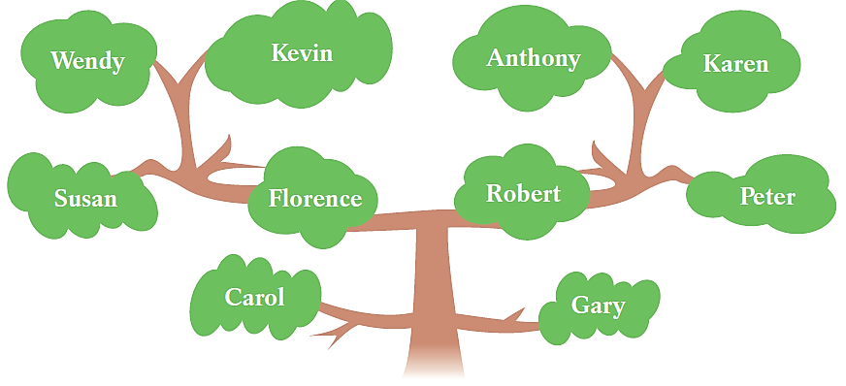
1.Florence and Susan are Wendy’s ____________.
2.Karen is Carol’s _____________.
3.Gary is Carol’s _____________.

Florence and Susan are _____________ Wendy.
Carol is _____________ the tree.
Gary is _____________ Carol.

While-listening
Listening1
Question：
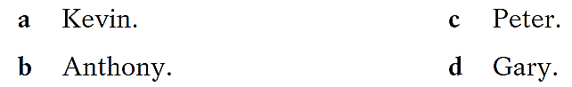
Day | Who | Activity
Thursday | _____ | ______
Friday | _____ | ______
Saturday | _____ | ______
Sunday | _____ | ______

Tip2
Listening2
Question：
Listening3-中考链接-信息转述
Listen to the conversation again and take down the key words (v. n. adj. adv. …).
1. On Thursday, Mum is …________________________
Tip3-信息转述
听前：准备答题区域
听中：第一遍记录要点信息；
第二遍记录连接和延展信息。
听后：组织答案，准确转述。
2. Sunday is no good either, …_____________________
3. On Friday, … ________________________________
4. So, … _____________________________________
5. Finally, the boy will … ________________________

定好时态，画出草稿布局，留空白
______________________________________________
______________________________________________
______________________________________________
______________________________________________
______________________________________________

你的介绍可以这样开始：A boy is talking with his Mum which day his parents can come to see his school play.

Task4-中考链接-询问信息
1. 你喜欢校园活动吗？

2. 你们学校多久举行一次校园活动？

Post-listening (team work)
In groups, ask your classmates the questions below and tick (√) the appropriate boxes.
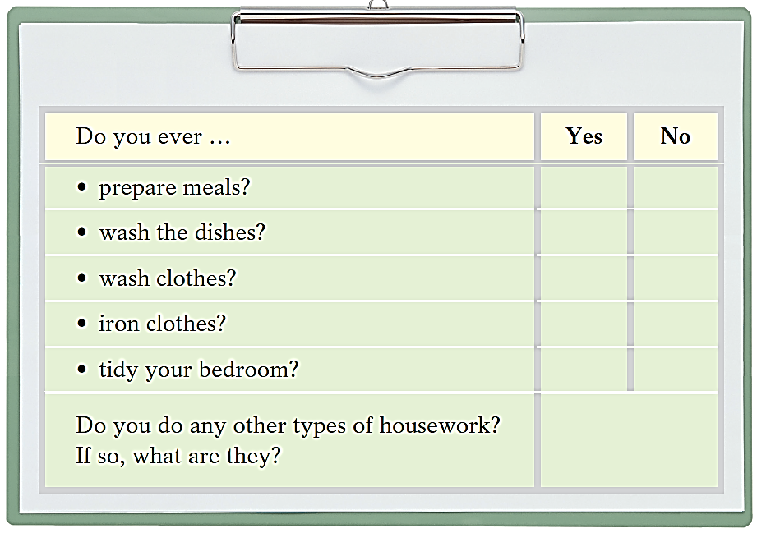
Make your report
There are five students in our group.
One student prepares meals. Four students don’t prepare meals.
Two students wash the dishes. Three students don’t wash the dishes.
…
…student(s) does/do some other
types of housework such as dusting, watering the plants, …
…
Summary
Skill（技巧）
利用“家庭树”理清家庭成员关系；
听取并记录关键信息，流利转述；
在提示词的帮助下复述故事；
Moral（道德启示）
关爱家人，积极参与家庭活动，做力所能及的家务，主动给别人提供帮助。

Homework
信息转述
Listen to Josh's story and take down the key words and then retell the story (v. n. adj. adv. …).
1. My name is Josh. __________________________________________
2. Last Monday, _____________________________________________
3. My dad works in __________________________________________
4. As soon as _______________________________________________
5. Afterwards, ______________________________________________
6. My mum feels better _______________________________________

