**Unit 4 Seasons**

**Reading I**

**【学习目标】**

1. 感知四季的不同，学习四季气候特征的主要信息；
2. 发现、了解文章结构，掌握句型表达；
3. 学会并运用it is adj to do sth谈论活动和感受；
4. 学会以思维导图形式介绍广州的四季，描述人们的日常活动；

**【学习重点】**学习四季特征、文章结构，掌握句型表达；

**【学习难点】**结合蛛网图介绍广州的四季，描述人们喜爱从事的活动；

**【学习过程】**

**Lead-in：**Free-talk about four seasons

**Pre-reading：**

1. 学生阅读副标题、标题，看图片，并回答四个关于四季的问题。

1.What is the weather like in spring? 2.What do people usually do in summer?

3.What do people like doing in autumn? 4.What do children like about winter?

**While-reading:（Important points）**

Step1 略读：Match the paragraphs with the seasons.

Step2 寻读：阅读spring，完成表格

|  |  |  |
| --- | --- | --- |
|  | weather | activities |
| spring | It starts to_____________.  It often ______. | It is exciting to______. |

阅读summer，回答问题

|  |  |  |
| --- | --- | --- |
|  | Weather | Activities |
| Summer | It is _____ and the Sun  ____________. | People like to ________ and ___________. |

2.which of the following activity is not mentioned in this paragraph?

A.go to the beach B.swim in the sea

C.eat ice cream D.above all

阅读autumn，回答问题

|  |  |  |
| --- | --- | --- |
|  | weather | activities |
| autumn | It is ____________________. | It is nice to _______________. |

2.According to the passage, the Greens can see______ in autumn.

A.soft wind B.rainy days C.different colors of leaves D.sunny days

4.阅读winter，回答问题

|  |  |  |
| --- | --- | --- |
|  | Weather | Activities |
| Winter | It is often___________. | Children love to _________. |

Step3 文章结构分析

1.已知weather和activities的信息，还有哪个方面未概括？

|  |  |  |  |  |
| --- | --- | --- | --- | --- |
|  | weather | changes | activities | Festival |
| spring | It starts to get warm.  It often rains. | _______________________ _______________________ _______________________ | It is exciting to take a trip. | / |
| summer | It is hot and the Sun shines brightly. | / | People like to go to the beach and swim in the sea. | / |
| autumn | It is cool and dry. | _______________________ _______________________ | It is nice to go on a picnic | / |
| winter | It is often cold and snowy. | / | Children love to play in the snow. | ____________ ____________ |

**句型：____________句型：____________ 句型：_________________**

**_____________ ______________**

**_____________**

2.用It is adj to do sth 句型口头描述图片活动

**Post-reading:（Difficult points）**How can we introduce the seasons Guangzhou?

1.根据蛛网图提示，以小组为单位，描述广州四季的天气和活动

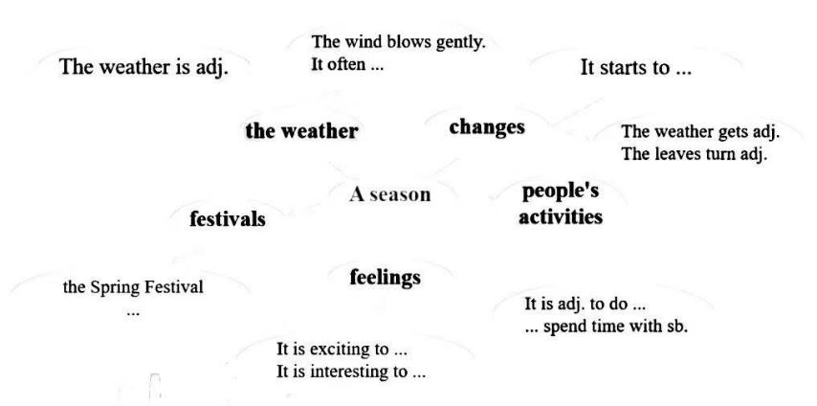

The season I want to introduce is ...（我想介绍的季节是....）

*weather, changes, people’s activities, feelings, festivals...*

Thank you for listening.

1. **Deep thinking**

What’s the differences of winter between the south and the north of China?

**Homework:**

1. Preview the text ***The weather in China*** P54.