**Unit 3 Protect the Earth**

**Writing**

**【学习目标】**

1. 学会认读、理解以及使用catch、problem、waste、rubbish、throw以及短语throw away、land pollution；

2.学会正确使用There be和it’s adj. for sb. to do 句型；

3.使用Unit 3 所学知识、句型以及词组，完成一份有关保护环境的写作；

**【学习重点、难点】**

**1.重点：1.根据所给的信息正确表达自己的观点，完成一份保护环境的写作；**

**2.如何正确使用there be句型和It’s adj. for sb. to do句型表达**

**2.难点：学生理解环境保护的重要性，树立保护环境保护的意识；**

**【学习过程】**

**Pre-writing：**

1. Analyze the structure of the parage 5-6 on page 31

**While-writing:（Important points）**

1. Watch a video about the problems of the Earth and write them down.

**2.Discussion**: Discuss the reason of pollution and things we can do**(Teamwork)**

|  |  |  |
| --- | --- | --- |
| **Problems** | **What do people do** | **Things we can do** |
|  |  |  |
|  |  |  |
|  |  |  |
|  |  |  |

**Some tips:**

**Give suggestions:**

**1.We should/can/must do.... 2.We shouldn’t/can’t/mustn’t do...**

**3.Try/ Remember/ Don’t forget to ... 4.We had better(not) do..**

**post-writing:（Difficult points）**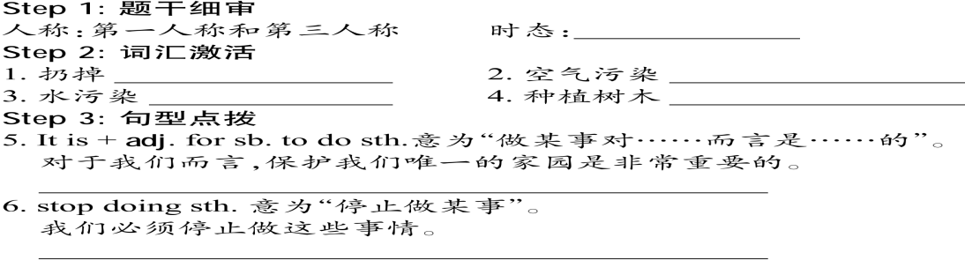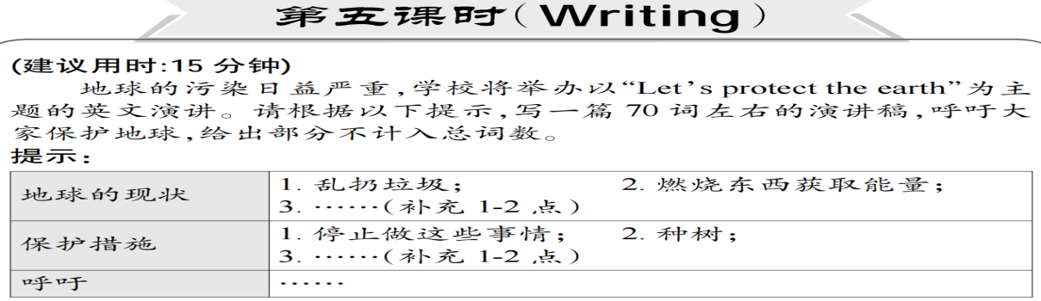

Good morning, boys and girls. I am happy to stand here and give my speech.__________________________________________________________________________________________________________________________________________________________________________________________________________________________________________________________________________________________________________________________________________________________________________________________________________________________________________________________________________________________________________________________________________________________________

__________________________________________________________________________________________________________________________________________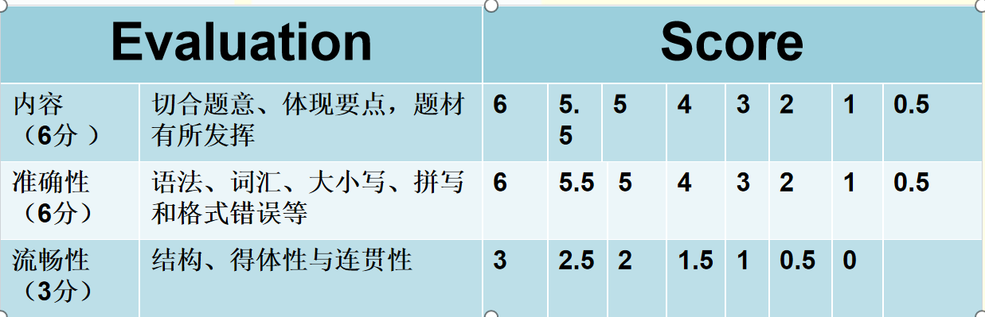

|  |  |  |  |
| --- | --- | --- | --- |
| **评分细则** | **内容（6分）** | **准确性（6分）** | **流畅性（3分）** |
| **自评** |  |  |  |
| **他评** |  |  |  |

**Homework:**

1. 继续完成writing 作文。
2. 思考题：What else problems do the Earth face now?whart are they? And how to sovle them?