**(八年级下册U3 Listening & Speaking)教学设计**

广州市花都区花广金狮学校 蔡泽文

1. **教学材料**

Level：Junior Two

Teaching Material: Oxford English Book8B P38、P42

Teaching content: Unit3 Traditional skills (Listening &Speaking)

Lesson type: Listening &Speaking

Lesson length: 40 minutes

1. **教学内容分析**

学生在阅读(Reading)板块阅读一篇描写中国古老技艺--鸬鹚捕鱼的短文，了解这项传承千年的古老记忆的现状与未来;在听力(Listening)板块听一段图片描述，然后圈出图片中的错误之处，并根据听到的内容回答问题，巩固根据所听内容记录关键信息的听力技能;在语法(Grammar)板块学习动词一般现在时，一般过去时和一般将来时的被动语态;在口语(Speaking)板块的功能意念(Talk time) 部分学习描述人物外貌的一般方法，然后在会话(Speak up)部分进一步讨论讨论剪纸这项传统技艺;在写作(Writing) 板块先阅读一篇描述捏面人艺人及其手艺的范文，然后参照范文的写作提纲，介绍自己熟悉的一位传统手工艺者及其手艺;在补充阅读(More practice)板块阅读一篇有关皮影戏的短文，并回答相关问题，然后根据篇章内容讨论皮影戏艺人如何表演皮影戏;在文化角(Culture corner)板块了解中国节的相关知识。

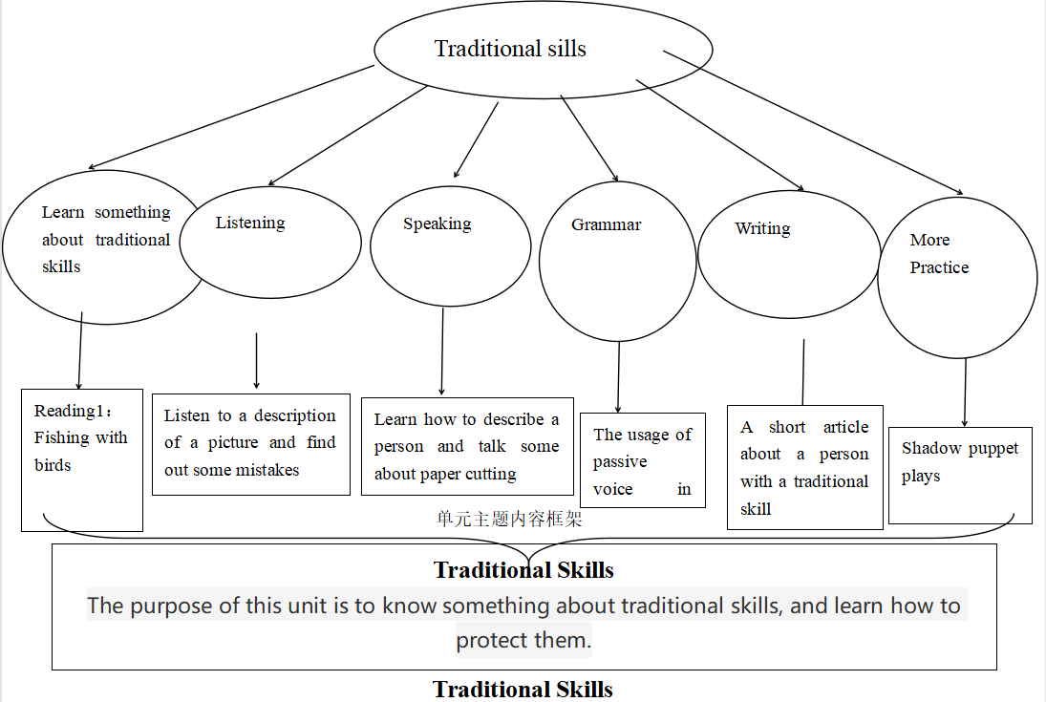

**三、学情分析：**

* Students in this class are a little below average. Some of them are outgoing and good at English, while mostof students are not interested in English and passive in class, so it is challenging to get them involved.
* Students may have some words about how to describe people, so it is easier for them to finish the task, but it is a little difficult for them to find out the mistakes about a picture and correct them because it is the first time that they have done listening task like this and their listening skills are far from satisfying.

**四、课时教学目标：**

* Learn to observe for detailed information and make prediction before listening
* Learn to catch the key words while listening.
* Under the description of a picture and be able to correct the mistakes.
* Learn to describe a person from different aspects.

**五、教学重难点：**

* Important point: To help the students to make some prediction.

To guide the students to correct the mistakes.

* Difficult point: To get the key information while listening and correct the mistakes.

**六、教学过程：**

|  |  |  |  |  |  |  |
| --- | --- | --- | --- | --- | --- | --- |
| 教学环节 | 教师活动 | 学生活动 | 设计意图 | 教学评价形式 | 评价内容 | 评价标准 |
| **Greeting and learning goal**  **(2’)** | 1. Greeting 2. Introduce the learning goals. | 1.Greeting.  2.know about the learning goals. | Let the students know what they are going to learn in this class so that they can make assessment at the end of this class. | Teacher evaluation |  | Accuracy |
| **Warming up and Lead in (2’)** | 1. Ask the students to find out the differences between two pictures and tell the teacher how to find them. 2. Lead in the first learning task. | 1. Observe the two pictures and find out the differences. 2. Tell the teacher how he/she find the differences. | To arouse the students’ interest and lead in what they are going to learn in the first part. | Teacher evaluation | Know something about how to find the difference. | Accuracy |
| **Pre-listening (3’)** | 1. Tell the students some tips about prediction.  2. Ask the students to observe the picture and focus on some details. | 1. Observe the picture. 2. Find some detailed information according to the tips. | 1. To make the students familiar with the listening material. 2. Prepare the students for what they are going to do next. | Teacher evaluation | Know about some details and make prediction | Accuracy |
| **While-listening(16)** | 1. Ask the students to do some listening tasks. 2. Check the answers. 3. Ask the students to listen for the second time and circle the mistakes. 4. Ask the students to listen again and correct the mistakes. 5. Give some sentence patterns to guide the students to correct the mistakes. | 1. Listen to the tape for the first time and choose the correct answers. 2. Listen for the second time and circle the mistakes. 3. Listen for the last time, discuss in the group and correct the mistakes by writing down the key words. 4. Correct the mistakes using the sentence patterns. | 1. Decrease the difficulty of the listening task. 2. Make the students understand the listening and finish the task by discussion. | Teacher evaluation | Listening skills  Speaking skills | Accuracy |
| **Speaking**  **(15’)** | 1. Ask students to brainstorm some aspects in describing a person. 2. Get the students to review some words they have learned about the features of people. 3. Prepare some names, ask the students to choose them and describe the person they choose. | **1.** Think about how to describe a person.  2. Review some adjectives to describe a person.  3. Group work: each group choose one person and the discuss in the group how to describe the person and the other students guess who the person is. | 1. Know some words about how to describe a person.   2. arouse the students’ interest in putting what they have learned into practice. | Teacher evaluation  Group evaluation | Describe a person correctly. | Ability of observing and expressing |
| **Summary&**  **Homework**  **(2’)** | 1. Conclusion. 2. Set the homework. | 1. Summarize what they have learned in this lesson. 2. Finish the homework. | To guide students to sum up what they have learned | Teacher  evaluation |  | Accuracy |

**七、板书设计**

|  |  |
| --- | --- |
| **Unit 3 Traditional Skills (Listening & Speaking)**   1. 改正图片错误   The picture shows that....  In fact, he/she/it should...   1. 描述人物   He/She is...  He/She has...  He/She wears... |  |

附学案

8B Unit 3 Listening& Speaking学案

1. Listen to the tape and choose the correct answers.

(1) What time is it?

It is ( 2:00 / 4:00 /6:00 ) p.m.

(2) Where are the people?

They are ( in the park / by the river / on the farm)

1. What color is the paper cutting artist’s shoes?

He is wearing a pair of ( white/ brown /black) shoes.

1. What is the woman on the right doing?

She is ( shouting / laughing / smiling).

1. How much is a paper picture?

It is ( 500/ 50 /5 ) yuan.

1. Circle the mistakes and write down the key words.

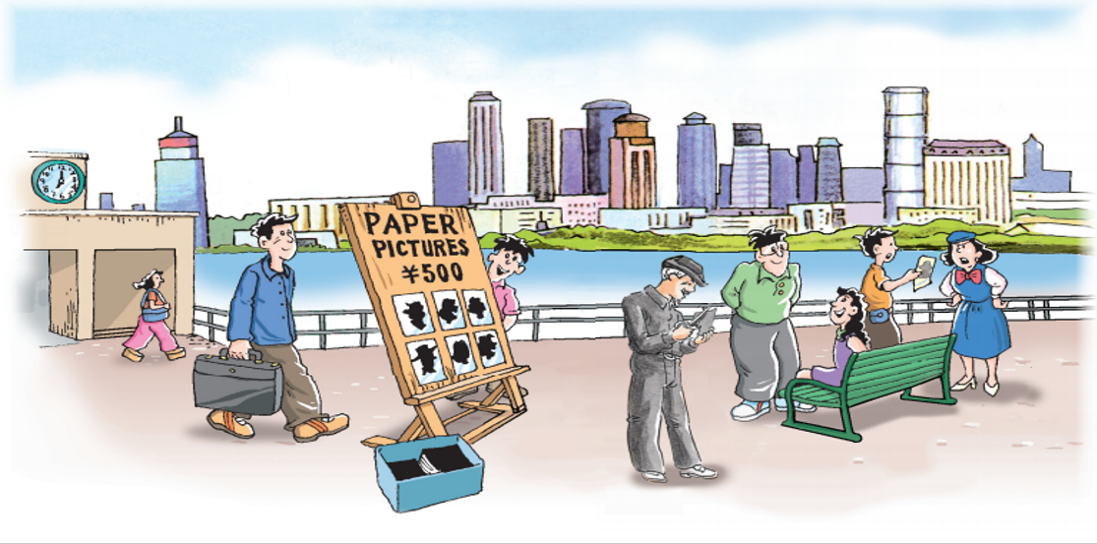

1. Correct the mistakes using the sentences patterns.
2. The picture shows___________________.

In fact, he/she/it should___________________.

(2) The picture shows the artist is an_________________________.

In fact, he/she/it should__________________________.

(3) The picture shows the artist is wearing __________________.

In fact, he/she/it should be wearing ____________________.

1. The picture shows the artist is wearing ______________________.

In fact, he/she/it should be wearing ___________________.

1. The picture shows the girl sitting on the bench has _______________.

In fact, he/she/it should ___________________.

1. The picture shows the price _________________________.

In fact, he/she/it should__________________________.

1. The picture shows the woman on the right__________________.

In fact, he/she/it should__________________________.

1. Group work

Each group choose one person and try to describe him/her, the other groups will guess who the person is according to what they hear.

He/She is...

He/She has...

He/She wears...